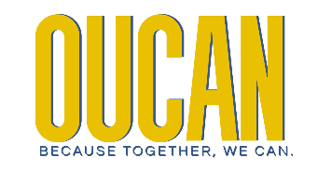

OUCAN - Ohio Urban Community Action Network
597 High Street, Box 538
Worthington OH, 43085

Ohio Urban Community Action Network
Women’s Leadership Symposium: When We Lead
March 14, 2024 | 10:00am

About the Women’s Leadership Symposium
In recognition of Women’s Herstory Month the Ohio Urban Community Action Network will host its annual Women’s Leadership Symposium: When We Lead on March 14, 2024. This year’s one-day virtual event explores the power of self-reimagination, self-advocacy and self-empowerment as women leaders, through open conversation, build professional skills and celebrate workplace champions.
OUCAN is thrilled to announce two keynote speakers for our third annual Women’s Leadership Symposium. The Honorable State Representative Juanita Brent (D-22) and the sought-after expert Emily Campbell, President/CEO of the Center for Community Solutions will headline a roster of incredible women.
We are excited to feature an outstanding roster of workshop presenters covering topics ranging from entrepreneurship, building wealth, mentorship, and providing a career pipeline opportunity for all girls and women to succeed. This is a statewide invitation designed for women leaders in urban community action agencies and human services organizations. Guests will have an opportunity to gain experience and network with other women leaders through a variety of open conversations including a special reception presented by Posh TeaTime Co. featuring Ms. Ella Williams, a panelist from last year’s Symposium.

Registration

This year’s Women Leadership Symposium: When We Lead is a one-day virtual event. Registration begins February 1, 2024, at $75 for OUCAN members and $100 for non-OUCAN members. Registration will not be accepted after March 11.

All registration fees must be paid in full by March 10.Payments may be received through OUCAN PayPal by clicking here or postal mail at OUCAN 597 High Street, Unit #538, Worthington, OH 43085. To request an invoice, please contact us at info@ohioucan.com.

Program Agenda

Thursday, March 14, 2024
10am – 10:25am Welcome & Introductions
10:25am – 10:55am Opening Keynote Address - When We Lead: Women in Leadership by The Honorable State Representative Juanita Brent (D-22)
11:00am – 11:30am Keynote Address – Status of Women in Ohio by Emily Campbell, President/CEO, Center for Community Solutions

11:30 – 11:45am Special Word by OUCAN Women Leaders

12:45am – 12:55pm Lunch on your Own

1:00pm – 1:55pm When We Lead Panel Discussion
When more women are empowered to lead, everyone benefits. Decades of studies show the dedication of women leaders increases productivity, enhances collaboration, inspires organizational excellence, and improves fairness. This expert panel of women leaders and bosses will share their secrets to leading authentically. They will also discuss the challenges they have overcome and the helpful strategies they use to lead with intention and grace.

Panelists: Brandi Slaughter, Freida Foster, Dr. Twana Black, and Amber Sellers, Lynnise Smith
2:00pm – 2:10pm Self-Care Break
2:15pm – 3:10pm Workshops | Breakout Sessions | Self-Select
Self-Empowerment: The future of Working with Multi-Generations: Wisdom from Millennials and Gen Z professionals

Program Agenda

Thursday, March 14, 2024

3:15pm – 4:15pm Self-Empowerment: The future of Working with Multi-Generations: Wisdom from Millennials and Gen Z professionals
Presenters: Nijah Golliday & Raven Golliday and Rebecca Kusner and Katie Brennan
---------------------------------------------------------------------------------
Self-Reimagination: Redesigning your Workspace & Workplace Passion
Presenters: Kioshana LaCount Burrell and Kirstin Buckner

Self-Reimagination: Redesigning your Workspace & Workplace Passion
Presenters: Angeline Johnson and Shirica Monroe
4:20pm – 5:00pm What’s the Tea? Leadership in Conversation & Action presented by Posh TeaTime Co. featuring Ms. Ella Williams
Participants are invited to spend a casual and relaxing teatime discussion donned in tea attire and accessories found in the special registration packages. We will create empowerment action steps for personal and professional development.

Presenter: Ella Williams
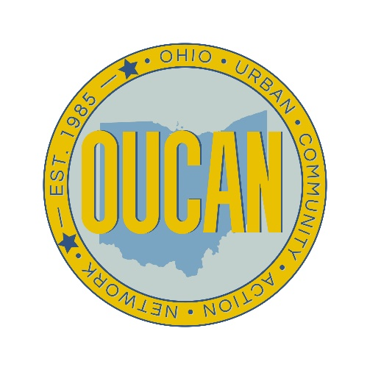

#OUCAN2K24 #WhenWeLead #BecauseTogetherWeCan
#WomenInLeadership #WLS2024
www.ohioucan.com
info@ohioucan.com

